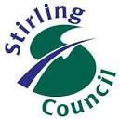 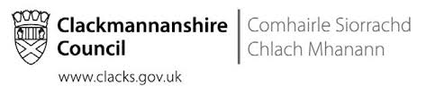 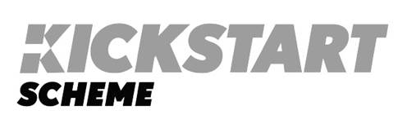

**Employer guidance and application template**

**Guidance**

Kickstart is part of the UK Government’s Plan for Jobs tackling some of the impact of COVID 19 and aims to create hundreds and thousands of new, fully funded positons across England, Scotland and Wales. The first placements are likely to be available from November 2020 and the scheme will run for 18 months.

The Kickstart Scheme provides funding to employers to create new 6-month job placements for 16 – 24 year olds who are currently on Universal Credit and at risk of long-term unemployment.

Funding will cover for each job placement:

* 100% of the relevant National Minimum Wage for 25 hours a week
* the associated employer National Insurance contributions
* employer minimum automatic pension enrolment contributions

Bidding for Kickstart places is a national process which is being routed through the Department of Work & Pensions (DWP). Any organisation can bid for places but applications must be for a minimum of 30 job placements and there is no upper limit.

However, across Forth Valley, as a result of our engagement with employers, local authorities recognise that setting a minimum of 30 placements through the bidding process excludes many small to medium business enterprises (SME’s).

Stirling, Falkirk and Clackmannanshire Councils have therefore agreed to adopt a regional approach to bidding for placements acting as a consortium and business intermediary so SME’s can take advantage of the opportunities presented through the Kickstart scheme.

Interested employers should complete the template below and return no later than **Monday 28th September 2020** to the following local authority e-mail contacts

Stirling Council [employerengagement@stirling.gov.uk](mailto:employerengagement@stirling.gov.uk)

Clackmannanshire Council [cworks@clacks.gov.uk](mailto:cworks@clacks.gov.uk)

Falkirk Council [etu@falkirk.gov.uk](mailto:etu@falkirk.gov.uk)

Employers should also direct any questions and queries to the e-mail addresses given above.

We will acknowledge receipt of your application.

**As a local authority consortium and Kickstart intermediary, we will endeavour to secure as many places as possible for local employers. However, completion of the template below is not a guarantee that a placement will be funded. We will work closely with applicants and aim to keep you fully informed as the process develops.**



|  |  |
| --- | --- |
| Business name and address |  |
| Key Contact |  |
| Telephone number |  |
| E-mail address |  |
| Brief description of your business | |
| How many job placement opportunities is your business planning to create? |  |
| What is/are the job title(s) | |
| Brief description of the role(s) to be undertaken | |
| As an employer are you considering offering more hours per job placement in addition to the 25hrs allocated through the Kickstart scheme? |  |
| Please provide additonal information about your business you feel might be relevant to your application e.g. total no. of employees, employee opportunities and support etc. | |
| When do you estimate your Kickstart job placement opportunity would begin? |  |
| Do you currently pay employees the minimum wage (yes/no) Please detail opposite |  |
| Do you currently pay employees the living wage? (yes/no) Please detail opposite |  |